**Assembler Project**

Project in CAO1, 3rd Semester. Counter project is made for counting, detecting movement of people passing through certain way. Project is made using Adeept Mega 2560 Arduino microcontroller.

**Problem statement**

What can be done to detect movement of people passing through certain way?

**Design**

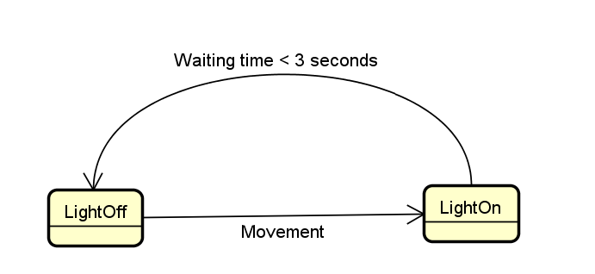

There are 2 possible states for the program

* LightOn - state where LED is on.
* LightOff - state where LED is off.

When there is movement in front of PIR Movement sensor program goes to LightOn state, after 3 seconds it goes back to LightOff state.

**Testing**

**Project diagram**

Things used:

1. 6 Wires
2. 1 PIR Movement sensor
3. 1 Adeept mega 2560 microcontroller board
4. 1 Breadboard
5. 1 LEDs
6. 1 220Ω resistors

PIR Movement sensor is connected to 3 wires, one is connected to ground to microcontroller, one is connected to 5V power to microcontroller and the other wire is connected to pin 3. Pin 2 from microcontroller is connected to breadboard where is connection to the LEDs. The resistor is connected to negative leg of LEDs.

